HAZARDOUS MATERIALS MANAGEMENT PLAN
(HMMP)

Vancouver Fire Department, Washington

Effective September 11, 2023

TABLE OF CONTENTS

What is a Hazardous Materials Management Plan? 4
What is the purpose of the Hazardous Materials Management Plan? 4
Who must complete a Hazardous Materials Management Plan? 4
What if I don’t handle any hazardous materials in amounts requiring an HMMP? 6
What information is required to be submitted with the Hazardous Materials Management Plan? 6
How often do I have to update my Hazardous Materials Management Plan? 6
Business Activities Declaration Instructions 9
Business Owner/Operator Identification Page Instructions 11
HMIS Hazard Class Summary Report Instructions 18
Emergency Response/Contingency Plan 19
Employee Training Plan 22
Record Keeping 23
Facility Site Plan and Storage Map 24
Facility Site Plan/Storage Map 25
Vancouver Fire Department 26
Refrigerant Declaration 26
Hazardous Materials Tank Plan 27
III. LIFE SAFETY MATRIX EXAMPLE 28
28
IV. FIRE PROTECTION SYSTEM INPUT/OUTPUT MATRIX EXAMPLE 29
29
Vancouver Fire Department 30
ENERGY STORAGE SYSTEMS (ESS) AND 30
LITHIUM-ION & LITHIUM-METAL BATTERY STORAGE NOTIFICATION 30
Authority Cited: International Fire Code 1207.1.3 & 1207.1.4 30
HIGH-PILED OR RACK STORAGE 36
SUPPLEMENTAL APPLICATION 36
AEROSOL STORAGE AND SALES 38
OWNER’S STATEMENT OF INTENDED USE 38
FLAMMABLE AND COMBUSTIBLE LIQUID STORAGE IN WHOLESALE AND RETAIL SALES 40
OWNER’S STATEMENT OF INTENDED USE 40

Vancouver Fire Department

HAZARDOUS MATERIALS

MANAGEMENT PLAN (HMMP)

All facilities that handle virgin or waste hazardous materials in the City of Vancouver must complete the Hazardous Activities Declaration and Business Owner/Operator Information portions of this Hazardous Materials Management Plan (HMMP). Additional elements of this HMMP may be required to be submitted depending on the quantities and hazards presented by the materials and the nature of the activities and processes conducted at the facility that involve hazardous materials.

This Hazardous Materials Management Plan, including the enclosed forms can be downloaded at https://www.cityofvancouver.us/government/department/vancouver-fire-department-vfd/building-construction-resources/

What is a Hazardous Materials Management Plan?

An HMMP is a document containing detailed information regarding the storage and use of hazardous materials at a facility. The International Fire Code Section 5001.5.1 authorizes the fire code official to require business owners/operators of facilities that use or store hazardous materials to submit this information.

What is the purpose of the Hazardous Materials Management Plan?

The intent of the HMMP is to provide detailed information to assist fire prevention officers evaluate compliance with fire protection and life safety requirements, and emergency responders who may be called to respond to an incident involving hazardous materials at the facility. All persons at the facility qualified to serve as emergency coordinators must be thoroughly familiar with the contents and use of the HMMP, with the operations and activities of the facility, and with the locations of hazardous materials records maintained by the facility.

This package has been developed to assist you in complying with the requirements of the state and local fire code to provide adequate information about the type, quantity of—and management practices regarding—hazardous materials that are stored or used at your facility.

Who must complete a Hazardous Materials Management Plan?

The owner/operator of a facility must complete and submit an HMMP:

- where hazardous materials are present above permit thresholds set forth in the International Fire Code at any time during the year,
- for select operations and activities set forth in the Facility Information Business Activities page included in this HMMP, and
- where otherwise required by the Vancouver Fire Marshal.

For some operations and activities, select elements of the HMMP, or supplemental information may be required to be submitted in accordance with the Facility Information Business Activities page.

What if I don’t handle any hazardous materials in amounts requiring an HMMP?

Facilities that are not required to complete an HMMP are still required to submit a Business Activities Declaration, Business Owner/Operator’s Identification, and may be required to submit a Hazardous Materials Inventory Statement (HMIS).

What information is required to be submitted with the Hazardous Materials Management Plan?

An HMMP must contain the following minimum elements:

- Business Activities Declaration page (Form and instructions attached)
- Business Owner/Operator Identification page (Form and instructions attached)
- Hazardous Materials Inventory Statement (HMIS) page(s) (Forms and instructions attached)
- HMIS Hazard Class Summary Report (Forms and instructions attached)
- Emergency Response/Contingency Plan (Sample forms and instructions attached)
- Employee Training Plan (Sample form and instructions attached)
- Recordkeeping (Sample form and instructions attached)
- Facility Site Plan & Storage Map (Sample form and instructions attached)

Depending on applicability, the following additional information may be required:

- Multi-tenant Building Control Area Agreement (Sample clauses and instructions attached)
- Refrigerant Declaration
- Lithium-ion or Lithium-metal Battery Storage Notification
- Biosafety Level-3 or -4 Notification
- Tank Plan
- Life Safety Matrix
- Energy Storage System (ESS) Notification
- High-piled or Rack Storage Supplemental Application
- Aerosol Storage and Sales – Owner’s Statement of Intended Use
- Flammable and Combustible Liquid Storage in Wholesale or Retail Sales – Owner’s Statement of Intended Use

How often do I have to update my Hazardous Materials Management Plan?

Within 30 days of the occurrence of any of the following events, the HMMP must be revised, and the revisions submitted to the Vancouver Fire Department, Fire Marshal’s Office:
- There is a 100% or more increase in the quantity of a previously disclosed material,
- The facility begins handling a previously undisclosed material at or above HMMP reporting thresholds,
- The facility changes address,
- Ownership of the facility changes, or
- There is a change of business name.

Additionally, if the Vancouver Fire Department determines that the HMMP is deficient in any way, the plan must be revised, and the revisions submitted within 30 days of the notice to submit a corrected plan.

Vancouver Fire Department
FACILITY INFORMATION
BUSINESS ACTIVITIES DECLARATION
Page____of ____
I. FACILITY IDENTIFICATION
FACILITY ID #  (Agency Use Only) |  |  |  |  |  |  | — |  |  |  |  |  |  |  |  | 1. |  | EPA ID # (Hazardous Waste Only) |  |  |  |  | 2.
BUSINESS NAME (Same as Facility Name or DBA - Doing Business As) |  |  |  |  |  |  |  |  |  |  |  |  |  |  |  |  |  |  |  |  |  |  | 3.
BUSINESS SITE ADDRESS |  |  |  |  |  |  |  |  |  |  |  |  |  |  |  |  |  |  |  |  |  |  | 103.
BUSINESS SITE CITY |  |  |  |  |  |  |  |  |  |  |  |  |  |  |  |  | 104. | WA |  |  | ZIP CODE |  | 105.
II. ACTIVITIES DECLARATION
NOTE: If you check YES to any item on this list,
please submit the Business Owner/Operator Identification page.
Does your business… |  |  |  |  |  |  |  |  |  |  |  |  |  | If YES, please complete these pages of the HMMP or Supplemental:
A. HAZARDOUS MATERIALS |  |  |  |  |  |  |  |  |  |  |  |  |  |  |  |  |  |  | ALL
Have on site (for any purpose) at any one time, hazardous materials, including hazardous waste, at or above 55 gallons for liquids, 500 pounds for solids, or 200 cubic feet for compressed gases (include liquids in ASTs and USTs)?
 |  |  |  |  |  |  |  |  |  |  |  |  |  | YES |  |  | NO | 4.
Have on site (for any purpose) at any one time, hazardous materials, including hazardous waste at or above the permit threshold set forth in Section 105.5 of the International Fire Code? Note: See attached permit thresholds. |  |  |  |  |  |  |  |  |  |  |  |  |  | YES |  |  | NO | 5. | HMIS  SITE MAP & STORAGE PLAN
B. TOXIC OR HIGHLY TOXIC GASES  Store or use any amount of toxic or highly toxic gases? |  |  |  |  |  |  |  |  |  |  |  |  |  | YES |  |  | NO | 6. | ALL
C. UNDERGROUND OR ABOVEGROUND STORAGE TANKS  Own or operate permanent or portable aboveground storage tanks (AST) or underground storage tanks (UST) containing hazardous materials? |  |  |  |  |  |  |  |  |  |  |  |  |  | YES |  |  | NO | 7. | HMIS | TANK PLAN
D. HAZMAT-RELATED OPERATIONS & ACTIVITIES
Conduct additive manufacturing (3D printing) operations? |  |  |  |  |  |  |  |  |  |  |  |  |  | YES |  |  | NO | 8. | HMIS | SITE MAP & STORAGE PLAN
Store, handle, or manufacture aerosol products? |  |  |  |  |  |  |  |  |  |  |  |  |  | YES |  |  | NO | 9.. | AEROSOL SUPPLEMENTAL | SITE MAP
Operate a carbon dioxide beverage dispensing system? |  |  |  |  |  |  |  |  |  |  |  |  |  | YES |  |  | NO | 10. | HMIS | SITE MAP & STORAGE PLAN
Conduct operations, such as woodworking, that produce combustible dust? |  |  |  |  |  |  |  |  |  |  |  |  |  | YES |  |  | NO | 11. | HMIS | SITE MAP & STORAGE PLAN
Conduct cutting and welding or other hot work operations? |  |  |  |  |  |  |  |  |  |  |  |  |  | YES |  |  | NO | 12. | HMIS | SITE MAP & STORAGE PLAN
Perform dry cleaning operations? |  |  |  |  |  |  |  |  |  |  |  |  |  | YES |  |  | NO | 13. | HMIS | SITE MAP & STORAGE PLAN
Store or use explosives or explosive materials, including blasting agents? |  |  |  |  |  |  |  |  |  |  |  |  |  | YES |  |  | NO | 14. | ALL
Conduct operations involving fiberglass or fiberglass resin? |  |  |  |  |  |  |  |  |  |  |  |  |  | YES |  |  | NO | 15. | HMIS | SITE MAP & STORAGE PLAN
Finish floors with Class I or Class II liquids? |  |  |  |  |  |  |  |  |  |  |  |  |  | YES |  |  | NO | 16. | HMIS | SITE MAP & STORAGE PLAN
Conduct fruit or crop ripening? |  |  |  |  |  |  |  |  |  |  |  |  |  | YES |  |  | NO | 17. | HMIS | SITE MAP & STORAGE PLAN
Perform fumigation or insecticidal fogging? |  |  |  |  |  |  |  |  |  |  |  |  |  | YES |  |  | NO | 18. | HMIS | SITE MAP & STORAGE PLAN
Store or display gunpowder or primers? |  |  |  |  |  |  |  |  |  |  |  |  |  | YES |  |  | NO | 19. | HMIS | SITE MAP & STORAGE PLAN
Store or use Hazardous Production Materials (HPM)? |  |  |  |  |  |  |  |  |  |  |  |  |  | YES |  |  | NO | 20. | ALL
Store hazardous materials on racks or in piles over 6 feet? |  |  |  |  |  |  |  |  |  |  |  |  |  | YES |  |  | NO | 21. | ALL
Manufacture organic coatings? |  |  |  |  |  |  |  |  |  |  |  |  |  | YES |  |  | NO | 22. | HMIS | SITE MAP & STORAGE PLAN
Use plant extraction or carbon dioxide enrichment systems? |  |  |  |  |  |  |  |  |  |  |  |  |  | YES |  |  | NO | 23. | ALL
Operate a mechanical refrigeration system? |  |  |  |  |  |  |  |  |  |  |  |  |  | YES |  |  | NO | 24. | SITE MAP | REFRIGERANT DECLARATION
Operate a repair garage or motor vehicle fueling station? |  |  |  |  |  |  |  |  |  |  |  |  |  | YES |  |  | NO | 25. | HMIS | SITE MAP & STORAGE PLAN
Fabricate semiconductors or perform similar high-tech operations? |  |  |  |  |  |  |  |  |  |  |  |  |  | YES |  |  | NO | 26. | ALL
Conduct spraying finishing or dipping operations? |  |  |  |  |  |  |  |  |  |  |  |  |  | YES |  |  | NO | 27. | ALL
E. ELECTICAL ENERGY STORAGE SYSTEM (ESS)  Operate or maintain a stationary or mobile electrical energy storage system (ESS) requiring a permit per IFC Section 105.5? |  |  |  |  |  |  |  |  |  |  |  |  |  | YES |  |  | NO | 28. | ESS-LIB NOTIFICATION  SITE MAP & STORAGE PLAN
F. LITHIUM-ION BATTERY STORAGE  Store more than 15 cubic feet of lithium-ion or lithium-metal batteries? |  |  |  |  |  |  |  |  |  |  |  |  |  | YES |  |  | NO | 29. | ESS-LIB NOTIFICATION  SITE MAP & STORAGE PLAN
G. BIOLOGICAL SAFETY LEVEL 3 OR 4 LABORATORIES  Conduct any BSL-3 or BSL-4 activities? |  |  |  |  |  |  |  |  |  |  |  |  |  | YES |  |  | NO | 30. | BSL NOTIFICATION

H. HIGH-PILED COMBUSTIBLE STORAGE  Store more than 500 square feet, including aisles, of:  - high-piled combustible storage in piles or on pallets, in racks or shelves where the material being stored exceeds twelve (12) feet in height, or,  - tires, Group A plastics, flammable liquids, idle pallets, or similar high hazard materials stored above six (6) feet in height. |  |  | YES |  | NO | 31. | HIGH-PILED OR RACK STORAGE SUPPLEMENTAL
I. MULTI-TENANT BUILDING  Share the building with any other business? |  |  | YES |  | NO | 32. | ALL
This building will not be used for one or more of the hazardous operations, processes or storage listed above.
This building is intended to be a speculation building without a tenant currently. The owner will notify the tenant that there may be special fire department requirements for one or more of the hazardous operations, processes or storage listed above, and will be advised to contact the fire department for permits prior to occupancy.
I declare that the information above is true and correct.

Name (Print): _______________________________ Title: _____________________________

Signature: __________________________________ Date: _____________________________

HAZARDOUS MATERIALS PERMIT THRESHOLDS (extracted from IFC 105.5)

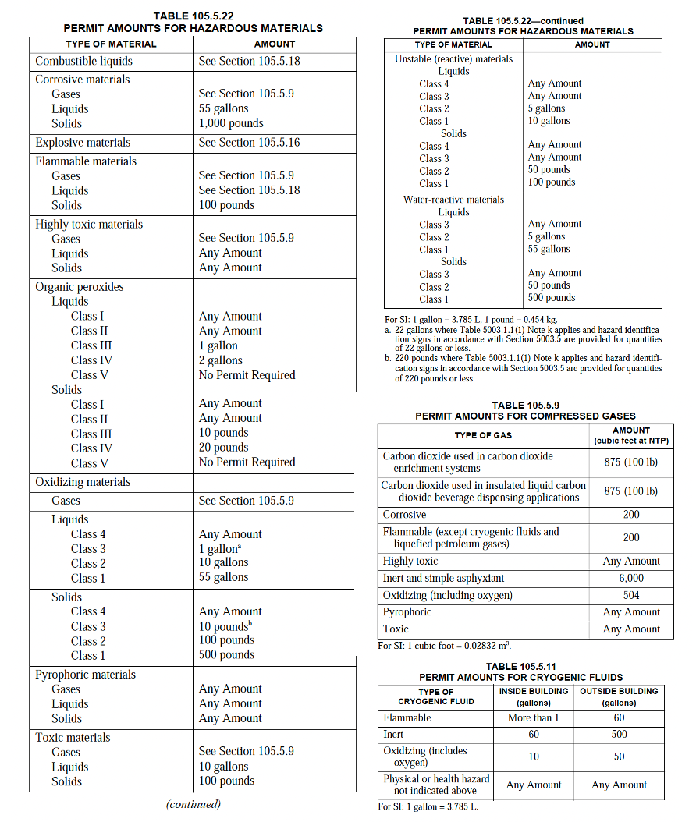

Business Activities Declaration Instructions

You must include the Business Activities Declaration with all HMMP submittals where the Business Owner/Operator Identification Page and/or hazardous materials inventory statement page(s) are submitted. [Note: Numbering of the following instructions follows Form Data Element numbers on the form. Please number all pages of your submittal.

- FACILITY ID NUMBER - This number is for agency use only. Leave this space blank.
- EPA ID NUMBER - Enter your facility's 12-character U.S. Environmental Protection Agency (USEPA) or Washington State Identification number if dangerous waste is generated or managed at the facility under Washington State Dangerous Waste Regulations as mandated by the Resource Conservation and Recovery Act (RCRA).
- BUSINESS NAME - Enter the complete Facility Name.
- BUSINESS SITE ADDRESS - Enter the street address where the facility is located, including building number, if applicable. Post office box numbers are not acceptable. This information must provide a means to locate the facility geographically.
- BUSINESS SITE CITY - Enter the city or unincorporated area in which the facility is located.
- ZIP CODE - Enter the 5- or 9-digit zip code for the facility.
- HAZARDOUS MATERIALS - Check the appropriate box to indicate whether you have any hazardous material on site in a quantity subject to Hazardous Materials Management Plan (HMMP) reporting requirements. If “YES,” you must submit a HMMP.
- HAZARDOUS MATERIALS - Check the appropriate box to indicate whether hazardous materials or compressed gases are stored or used on site in quantities exceeding the permit thresholds set forth in IFC §105.5.
- TOXIC and HIGHLY TOXIC GAS – Indicate whether any amount of toxic or highly toxic gases are stored or used indoors or outdoors onsite.
- UNDERGROUND (UST) & ABOVE GROUND STORAGE TANKS (AST) - Check the appropriate box to indicate whether you own or operate USTs or ASTs containing hazardous materials.
- ADDITIVE MANUFACTURING - Indicate whether additive manufacturing operations regulated by IFC §320.3 are conducted.
- AEROSOL PRODUCTS – Specify whether the facility manufactures, stores, or handles an aggregate quantity of Level 2 or Level 3 aerosol products, aerosol cooking spray products or plastic aerosol 3 products in excess of 500 pounds (227 kg) net weight.
- CARBON DIOXIDE BEVERAGE DISPENSING – Indicate whether carbon dioxide in a quantity exceeding 875 cubic feet at NTP (100 pounds) is used on site in insulated liquid carbon dioxide beverage dispensing applications.
- COMBUSTIBLE DUST – Specify whether the facility conducts operations that produce combustible dust as defined by the IFC.
- CUTTING & WELDING – Specify whether cutting and welding or other hot work is conducted on site.
- DRY CLEANING – Indicate whether your business engages in the business of dry cleaning.
- EXPLOSIVES & EXPLOSIVE MATERIALS – Indicate whether the business manufactures, stores, handles, sells or uses any quantity of explosives, explosive materials, fireworks, or pyrotechnic special effects.
- FIBERGLASS OPERATIONS – Specify if operations involving fiberglass, or fiberglass resin are conducted onsite.
- FLOOR FINISHING – Specify whether the business conducts floor finishing or surfacing operations exceeding 350 square feet (33 m2) using Class I or Class II liquids.
- FRUIT RIPENING - Indicate whether the business operates a fruit- or crop-ripening facility or uses ethylene gas to ripen fruit.
- FUMIGTION & INSECTICIDAL FOGGING – Specify if this business conducts fumigation or insecticidal fogging, or maintains a room, vault, or chamber in which a toxic or flammable fumigant is used.
- GUNPOWDER & PRIMERS – Indicate whether the business stores or displays gunpowder and/or primers.
- HPM – Indicate whether hazardous production materials (HPM) are stored, handled, or used at the facility.
- HIGH-PILED HAZARDOUS MATERIAL STORAGE – Specify whether any portion of the facility contains more than 500 square feet (46 m²), including aisles, of hazardous material stored on racks or in piles in excess of 6 feet.
- ORGANIC COATINGS – Indicate whether organic-coating manufacturing operation producing more than 1 gallon (4 L) of an organic coating in one day are conducted on site.
- PLANT EXTRACTION – Specify whether plant extraction or carbon dioxide enrichment systems are used.
- REFRIGERATION SYSTEM – Indicate whether a mechanical refrigeration unit or system regulated by IFC Chapter 6 is operated on site.
- REPAIR GARAGE OR MOTOR VEHICLE FUEL DISPENSING – Specify whether the facility engages in motor vehicle fuel dispensing or operates a repair garage.
- SEMICONDUCTOR MANUFACTURING – Indicate whether the facility is a semiconductor manufacturing facility or has a comparable research and development area classified as a Group H-5 occupancy.
- SPRAYING OR DIPPING – Specify whether spraying or dipping operations utilizing flammable or combustible liquids, or the application of combustible powders is conducted on site.
- ENERGY STORAGE SYSTEM (ESS) – Indicate whether a stationary or mobile ESS regulated by IFC §1207 is present at the facility.
- LITHIUM-ION OR LITHIUM-METAL BATTERY STORAGE – Specify whether an aggregate volume of more than 15 cu. ft. of lithium-ion and/or lithium-metal batteries are stored at the facility.
- BIOLOGICAL SAFETY LEVEL 3 OR 4 ACTIVITIES – Acknowledge whether any BSL-3 or BSL-4 activities are conducted at the facility.
- HIGH-PILED OR RACK STORAGE – Indicate whether high-piled or rack storage of combustible materials will be present in the facility.
- MULTI-TENANT BUILDING - Check the appropriate box to indicate whether the facility operates in a multi-tenant building.

Vancouver Fire Department
FACILITY INFORMATION
BUSINESS OWNER/OPERATOR IDENTIFICATION
Page of
I. IDENTIFICATION
FACILITY ID #  (Agency Use Only) |  |  | — |  |  |  | — |  |  |  |  |  |  |  | 1. | BEGINNING DATE |  |  |  |  | 100. |  | ENDING DATE | 101.
BUSINESS NAME (Same as Facility Name or DBA – Doing Business As) 3. |  |  |  |  |  |  |  |  |  |  |  |  |  |  |  |  |  |  |  | BUSINESS PHONE  ( ) |  |  |  | 102.
BUSINESS SITE ADDRESS 103. |  |  |  |  |  |  |  |  |  |  |  |  |  |  |  |  |  |  |  | BUSINESS FAX  ( ) |  |  |  | 102a.
BUSINESS SITE CITY 104. |  |  |  |  |  |  |  |  |  |  | WA |  | ZIP CODE 105. |  |  |  |  |  |  | COUNTY |  |  |  | 108.
DUN & BRADSTREET 106. |  |  |  |  |  |  |  |  |  |  |  |  | PRIMARY SIC 107. |  |  |  |  |  |  | PRIMARY NAICS |  |  |  | 107a.
BUSINESS MAILING ADDRESS |  |  |  |  |  |  |  |  |  |  |  |  |  |  |  |  |  |  |  |  |  |  |  | 108a.
BUSINESS MAILING CITY 108b. |  |  |  |  |  |  |  |  |  |  |  |  |  |  |  |  | STATE |  |  |  | 108c. | ZIP CODE |  | 108d.
BUSINESS OPERATOR NAME 109. |  |  |  |  |  |  |  |  |  |  |  |  |  |  |  |  |  | BUSINESS OPERATOR PHONE  ( ) |  |  |  |  |  | 110.
II. BUSINESS OWNER
OWNER NAME 111. |  |  |  |  |  |  |  |  |  |  |  |  |  |  |  |  |  | OWNER PHONE  ( ) |  |  |  |  |  | 112.
OWNER MAILING ADDRESS |  |  |  |  |  |  |  |  |  |  |  |  |  |  |  |  |  |  |  |  |  |  |  | 113.
OWNER MAILING CITY 114. |  |  |  |  |  |  |  |  |  |  |  |  |  |  |  |  | STATE |  |  |  | 115. | ZIP CODE |  | 116.
III. ENVIRONMENTAL CONTACT
CONTACT NAME 117. |  |  |  |  |  |  |  |  |  |  |  |  |  |  |  |  |  | CONTACT PHONE  ( ) |  |  |  |  |  | 118.
CONTACT MAILING ADDRESS 119. |  |  |  |  |  |  |  |  |  |  |  |  |  |  |  |  |  | CONTACT EMAIL |  |  |  |  |  | 119a.
CONTACT MAILING CITY 120. |  |  |  |  |  |  |  |  |  |  |  |  |  |  |  |  | STATE |  |  |  | 121. | ZIP CODE |  | 122.
-PRIMARY- IV. EMERGENCY CONTACTS |  |  |  |  |  |  |  |  |  |  |  |  |  |  |  |  |  |  |  |  |  | -SECONDARY-
NAME 123. |  |  |  |  |  |  |  |  |  |  |  |  | NAME |  |  |  |  |  |  |  |  |  |  | 128.
TITLE 124. |  |  |  |  |  |  |  |  |  |  |  |  | TITLE |  |  |  |  |  |  |  |  |  |  | 129.
BUSINESS PHONE 125.  ( ) |  |  |  |  |  |  |  |  |  |  |  |  | BUSINESS PHONE  ( ) |  |  |  |  |  |  |  |  |  |  | 130.
24-HOUR PHONE 126.  ( ) |  |  |  |  |  |  |  |  |  |  |  |  | 24-HOUR PHONE  ( ) |  |  |  |  |  |  |  |  |  |  | 131.
MOBILE PHONE # 127.  ( ) |  |  |  |  |  |  |  |  |  |  |  |  | MOBILE PHONE #  ( ) |  |  |  |  |  |  |  |  |  |  | 132.
ADDITIONAL COLLECTED INFORMATION:  Billing Address:  Property Owner: Phone No.: ( ) |  |  |  |  |  |  |  |  |  |  |  |  |  |  |  |  |  |  |  |  |  |  |  | 133.
Certification: Based on my inquiry of those individuals responsible for obtaining the information, I certify under penalty of law that I have personally examined and am familiar with the information submitted and believe the information is true, accurate, and complete.
SIGNATURE OF OWNER/OPERATOR OR DESIGNATED REPRESENTATIVE |  |  |  |  |  |  |  |  |  |  |  |  |  | DATE 134. |  |  |  |  | NAME OF DOCUMENT PREPARER |  |  |  |  | 135.
NAME OF SIGNER (print) 136. |  |  |  |  |  |  |  |  |  |  |  |  |  | TITLE OF SIGNER |  |  |  |  |  |  |  |  |  | 137.

Business Owner/Operator Identification Page Instructions
You must include the Business Owner/Operator Identification page whether an HMMP is required to be submitted or not. [Note: Numbering of the following instructions follows the Form Data Element numbers on the form.] Please number all pages of your HMMP submittal.
1. FACILITY ID NUMBER - This number is for agency use only. Leave this space blank.
3. BUSINESS NAME - Enter the complete Facility Name.
- BEGINNING DATE - Enter the beginning year and date of the report.
- ENDING DATE - Enter the ending year and date of the report.
- BUSINESS PHONE - Enter the phone number, including area code and any extension.
102a. BUSINESS FAX - Enter the fax number, including area code.
- BUSINESS SITE ADDRESS - Enter the street address where the facility is located, including building number, if applicable. Post office box numbers are not acceptable. This information must provide a means to locate the facility geographically.
- CITY - Enter the city or unincorporated area in which the facility is located.
- ZIP CODE - Enter the 5- or 9-digit zip code for the facility.
- DUN & BRADSTREET - If the business has a D&B number, enter it here.
- SIC CODE - Enter the 4-digit Standard Industrial Classification Code number for the facility's primary business activity.
107a. NAICS NUMBER – Enter the primary North American Industrial Classification System number.
- COUNTY - Enter the name of the county in which the facility is located.
108a. BUSINESS MAILING ADDRESS - Enter the facility's street or P.O. box mailing address, if different from the site address.
108b. BUSINESS MAILING CITY - Enter the name of the city for the facility's mailing address.
108c. BUSINESS MAILING STATE - Enter the 2-character state abbreviation for the facility's mailing address.
108d. BUSINESS MAILING ZIP CODE - Enter the 5 or 9-digit zip code for the facility's mailing address.
- BUSINESS OPERATOR NAME - Enter the name of the facility operator.
- BUSINESS OPERATOR PHONE - Enter the operator's phone number, including area code and any extension.
- OWNER NAME - Enter the name of the facility owner, if different from the operator.
- OWNER PHONE - Enter the owner's phone number, including area code and any extension.
- OWNER MAILING ADDRESS - Enter the owner's street or P.O. box mailing address, if different from the site address.
- OWNER MAILING CITY - Enter the name of the city for the owner's mailing address.
- OWNER MAILING STATE - Enter the 2-character state abbreviation for the owner's mailing address.
- OWNER MAILING ZIP CODE - Enter the 5- or 9-digit zip code for the owner's mailing address.
- ENVIRONMENTAL CONTACT NAME - Enter the name of the person, if different from the Business Owner or Operator, who will receive all environmental correspondence and will respond to enforcement activity.
- CONTACT PHONE - Enter the environmental contact's phone number, including area code and any extension.
- CONTACT MAILING ADDRESS - Enter the street or P.O. box mailing address where all environmental contact correspondence should be sent, if different from the site address.
119a. CONTACT EMAIL ADDRESS - Enter the Environmental Contact’s e-mail address.
- CONTACT MAILING CITY - Enter the name of the city for the environmental contact's mailing address.
- CONTACT MAILING STATE - Enter the 2-character state abbreviation for the environmental contact's mailing address.
- CONTACT MAILING ZIP CODE - Enter the 5- or 9-digit zip code for the environmental contact's mailing address.
- PRIMARY EMERGENCY CONTACT NAME - Enter the name of a representative (i.e., Emergency Coordinator) who can be contacted in case of an emergency involving hazardous materials at the facility. This person shall have full facility access, site familiarity, and authority to make decisions for the business regarding incident mitigation.
- TITLE - Enter the title of the primary Emergency Coordinator.
- BUSINESS PHONE - Enter primary Emergency Coordinator's business phone number, including area code and any extension.
- 24-HOUR PHONE - Enter a phone number that will be answered 24 hours a day. If not the primary Emergency Coordinator's home phone number, then the number of an answering service able to immediately contact the primary Emergency Coordinator must be provided. Please note that this is a public document, so any telephone number provided is available to the general public any time a review of your facility's records is conducted.
- PAGER NUMBER - Enter the pager number for the primary Emergency Coordinator, if available.
- SECONDARY EMERGENCY CONTACT NAME - Enter the name of a secondary Emergency Coordinator who can be contacted if the primary Emergency Coordinator is not available. The contact shall have full facility access, site familiarity, and authority to make decisions for the business regarding incident mitigation.
- TITLE - Enter the title of the secondary Emergency Coordinator.
- BUSINESS PHONE - Enter secondary Emergency Coordinator's business phone number, including area code and any extension.
- 24-HOUR PHONE - Enter a phone number for the secondary Emergency Coordinator. See instructions for item 126, above.
- PAGER NUMBER - Enter the pager number for the secondary Emergency Coordinator, if available.
- ADDITIONAL LOCALLY COLLECTED INFORMATION - Enter the complete mailing address to which bills for permit fees should be sent, if different from items 119-122, above. Enter the name and phone number for the property owner.
SIGNATURE OF OWNER/OPERATOR OR DESIGNATED REPRESENTATIVE - The Business Owner/Operator, or officially designated representative of the Owner/Operator, shall sign in the space provided. This signature certifies that the signer is familiar with the information submitted, and that based on the signer's inquiry of those individuals responsible for obtaining the information, it is the signer's belief that the submitted information is true, accurate, and complete.
- DATE - Enter the date that the document was signed.
- NAME OF DOCUMENT PREPARER - Type or print the full name of the person who prepared the Business Plan information.
- NAME OF SIGNER - Type or print the full name of the person signing this document.
- TITLE OF SIGNER - Enter the title of the person signing this document.

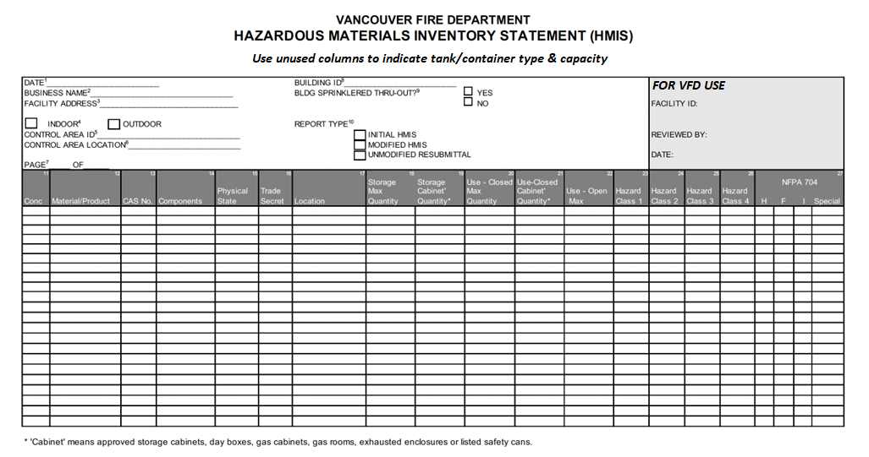

Download the template here: https://www.cityofvancouver.us/wp-content/uploads/2023/10/HMIS_Template_VFD.xlsm

Example of a Completed Hazardous Materials Inventory Statement (HMIS)

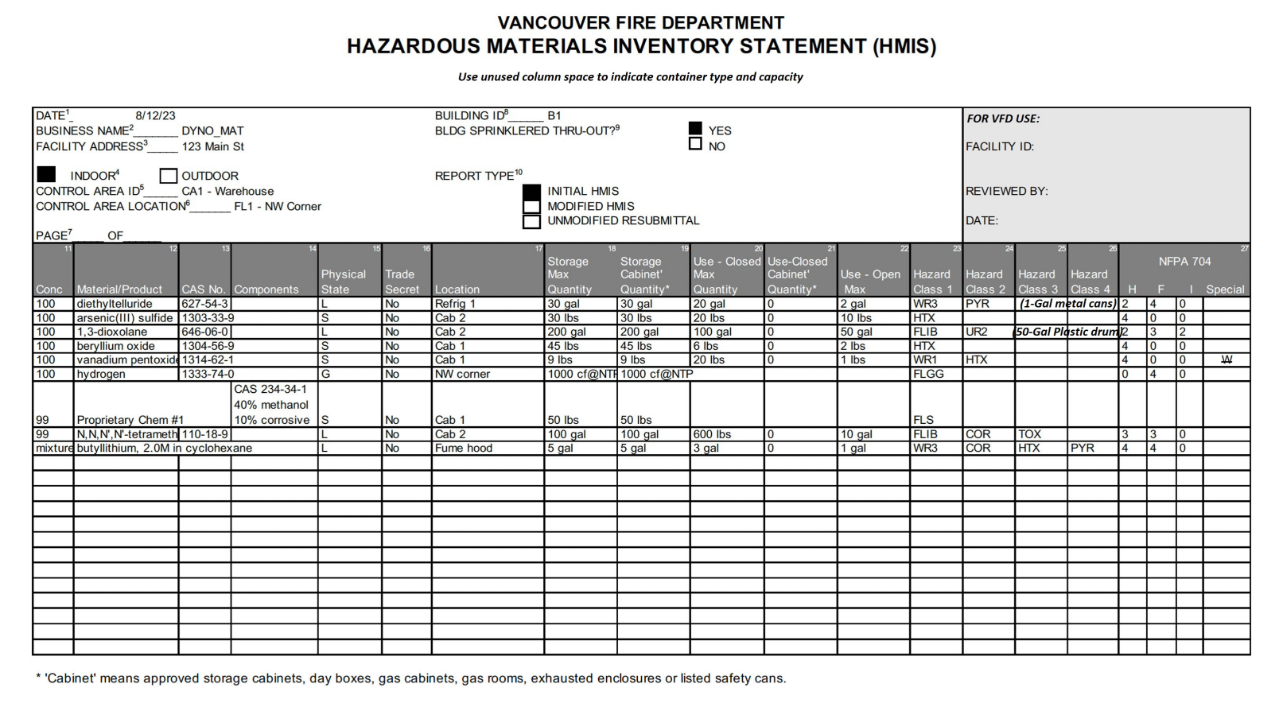
Hazardous Materials Inventory Statement Instructions

All hazardous materials stored or used at the facility must be listed on an approved Hazardous Materials Inventory Statement (HMIS). You must complete a separate HMIS for each indoor and outdoor control area and each Group H occupancy room or area.
A separate inventory line must be provided for each individual hazardous material that you store or handle at your facility. The completed inventory must reflect all reportable materials at your facility with a separate inventory line for unique occurrences of physical state, concentration, storage temperature, and storage pressure. Trade secret materials must be listed on separate pages. Make additional copies of this form if needed.

- DATE - In the space at the top left side of the form, enter the date this inventory statement page was prepared.
- BUSINESS NAME - Enter the complete Facility Name.
- FACILITY ADDRESS – Enter the Facility Address.
- INDOOR / OUTDOOR – Indicate whether the inventory chemicals are located Indoors or Outdoors.
- CONTROL AREA ID – Enter the name of the Control Area. This is a user-defined field.
- CONTROL AREA LOCATION – Identify the specific location of the Control Area, including the building floor level if indoors.
- PAGE NUMBER – Enter the applicable page number and the total number of pages contained in the HMIS.
- BUILDING ID – Enter the name or ID of the Building containing the Control Area or Group H occupancy this HMIS represents. This is a user-defined field.
- BUILDING SPRINKLERED THROUGHOUT – Specify whether the building containing the control area is sprinklered throughout.
- TYPE OF REPORT - Indicate whether this is a new HMIS, a revised HMIS or if the HMIS is an unmodified resubmittal.
- CONCENTRATION - % BY WEIGHT - Enter the percentage weight of the material. If a range of percentages is available, report the highest percentage in that range.
- MATERIAL OR COMMON NAME – Enter the Material name or Common name of the hazardous material or mixture (e.g., Gasoline, Acme Super Solvent).
- CAS NUMBER - Enter the Chemical Abstract Service (CAS) number for the hazardous material. For mixtures, enter the CAS number of the mixture if it has been assigned a number distinct from its components. If the mixture has no CAS number, leave this column blank and report the CAS numbers of the individual hazardous components in the appropriate section, below.
- HAZARDOUS COMPONENTS - (Note: If the material is not a mixture, skip Column 14 and go directly to Column 15.) In column 14, enter the following information regarding Hazardous Components that make up the material listed in Column 12:
  - CHEMICAL NAME - If the Chemical Name is the same as the Common or Trade Name shown in Column 12, you may leave this space blank. If the material is a mixture, list the chemical name of each hazardous component in the mixture ranked by percent weight (refer to the SDS or manufacturer). All hazardous components present at greater than 1% by weight if non-carcinogenic, or 0.1% by weight if carcinogenic, must be reported. If more than five hazardous components exceed these percentages, you may attach an additional sheet of paper to report the required information.
  - % BY WEIGHT - Enter the percentage weight of each hazardous component. If a range of percentages is available, report the highest percentage in that range.
  - CAS NUMBER - List the Chemical Abstract Service (CAS) number for each hazardous component.
- PHYSICAL STATE - In column 15, identify the physical state by entering S for “solid”, L for “liquid”, and G for “gas”. If the Gas is liquefied, indicate LG. If the gas is gaseous, indicate GG. If the gas is a cryogen, indicate G.
- TRADE SECRET - Check "Yes" if the information in this section is declared a trade secret, "No" if it is not. If "Yes," and the business is subject to EPCRA, disclosure of designated Trade Secret information is bound by 40 CFR and the business must submit a "Substantiation to Accompany Claims of Trade Secrecy" form to the United States Environmental Protection Agency.
- LOCATION - Enter a specific location in the area where the hazardous material is handled. This might be a specific lab room, or a storage cabinet identified on the Site Plan or Storage Map. A chemical stored at the same pressure and temperature in multiple locations in one building or area can be reported on a single line.
- STORAGE MAX QUANTITY - Enter the maximum amount of the hazardous material or mixture STORED in this control area, Group H occupancy or outside area at any one time over the course of the year. This amount must contain, at a minimum, last year's reported inventory with the reflection of additions, deletions, or revisions projected for the current year.
- STORAGE CABINET QUANTITY – Specify the amount of the stored material that is confined to approved storage cabinets, day boxes, gas cabinets, gas rooms, exhausted enclosures, or listed safety cans.
- USE-CLOSED MAX QUANTITY - Enter the maximum amount of the hazardous material or mixture in closed use in this control area, Group H occupancy or outside area at any one time over the course of the year. This amount must contain, at a minimum, last year's reported inventory with the reflection of additions, deletions, or revisions projected for the current year.
- USE-CLOSED CABINET QUANTITY – Specify the amount of the material that is in closed-use in approved cabinets, day boxes, gas cabinets, gas rooms, exhausted enclosures, or listed safety cans.
- USE-OPEN MAX QUANTUTY - Enter the maximum amount of the hazardous material or mixture in open use in this control area, Group H occupancy or outside area at any one time over the course of the year. This amount must contain, at a minimum, last year's reported inventory with the reflection of additions, deletions, or revisions projected for the current year.
- HAZARD CLASS 1 – All hazards associated with a hazardous material need to be reported. Enter a single Fire Code hazard class associated with the material in this column. If there are multiple hazard classes to report, use additional available columns. Use the hazard class abbreviations provided to properly report the material hazards. [See attached IFC/IBC Hazard Class Abbreviations]
- HAZARD CLASS 2 - Enter a single Fire Code hazard class associated with the material in this column. If there are multiple hazard classes to report, use additional available columns. Use the hazard class abbreviations provided to properly report the material hazards. [See attached IFC/IBC Hazard Class Abbreviations]
- HAZARD CLASS 3 - Enter a single Fire Code hazard class associated with the material in this column. If there are multiple hazard classes to report, use additional available columns. Use the hazard class abbreviations provided to properly report the material hazards. [See attached IFC/IBC Hazard Class Abbreviations]
- HAZARD CLASS 4 - Enter a single Fire Code hazard class associated with the material in this column. If there are multiple hazard classes to report, use additional available columns. Use the hazard class abbreviations provided to properly report the material hazards. [See attached IFC/IBC Hazard Class Abbreviations]
- NFPA 704 HEALTH (H) – Enter the Health hazard rating (0-4) assigned to this material based on the NFPA 704 Standard System for the Identification of the Hazards of Materials for Emergency Response.
NFPA 704 FLAMMABILITY (F) – Enter the Flammability hazard rating (0-4) of this material based on the NFPA 704 Standard System for the Identification of the Hazards of Materials for Emergency Response.
NFPA 704 INSTABILITY (I) - Enter the Instability rating (0-4) assigned to this material based on the NFPA 704 Standard System for the Identification of the Hazards of Materials for Emergency Response.
NFPA 704 SPECIAL – If applicable, enter the appropriate symbol to reflect water reactivity (W) or oxidizing (OX) properties associated with the material. It is acceptable to indicate SA in this column for simple asphyxiant gases such as nitrogen, helium, neon, argon, krypton, and xenon.

Vancouver Fire Department
Hazardous Materials Inventory Statement (HMIS)
Hazard Classes Abbreviations

HAZARD CLASS | ABBR. | HAZARD CLASS | ABBR.
Combustible dust | COMD | Oxidizing Gas
Combustible fibers |  | Gaseous gas | OXGG
loose | COMFL | Liquefied gas | OXLG
baled | COMFB | Pyrophoric | PYR
Combustible liquids |  | Unstable (reactive)
II | CLII | 4 | UR4
IIIA | CLIIIA | 3 | UR3
IIIB | CLIIIB | 2 | UR2
Cryogenic |  | 1 | UR1
Flammable | CRYF | Water reactive
Inert | CRYI | 3 | WR3
Oxidizing | CRYO | 2 | WR2
Explosives |  | 1 | WR1
1.1 | EXP1.1
1.2 | EXP1.2 | Corrosive | COR
1.3 | EXP1.3 | Gaseous gas | CORGG
1.4 | EXP1.4 | Liquefied gas | CORLG
1.4G | EXP1.4G
1.5 | EXP1.5 | Toxic | TOX
1.6 | EXP1.6 | Gaseous gas | TOXGG
Flammable Gas |  | Liquefied gas | TOXLG
Gaseous gas | FLGG
Liquefied gas | FLLG | Highly Toxic | HTX
Flammable Liquid |  | Gaseous gas | HTXGG
IA | FLIA | Liquefied gas | HTXLG
IB | FLIB
IC | FLIC | Aerosols
Flammable Solid | FLS | Level 3 | AER3
Inert Gas |  | Level 2 | AER2
Gaseous gas | INGG | Level 1 | AER1
Liquefied gas | INLG
Organic Peroxide
UD | OPUD | Not regulated:
I | OPI | Irritant | IRR
II | OPII | Sensitizer | SEN
III | OPIII | Radioactive | RAD
IV | OPIV | Carcinogen | CAR
V | OPV | Other Health Hazard | OHH
Oxidizer |  | Asphyxiant | ASPX
4 | OX4
3 | OX3
2 | OX2
1 | OX1

HMIS Hazard Class Summary Report (Partial view)

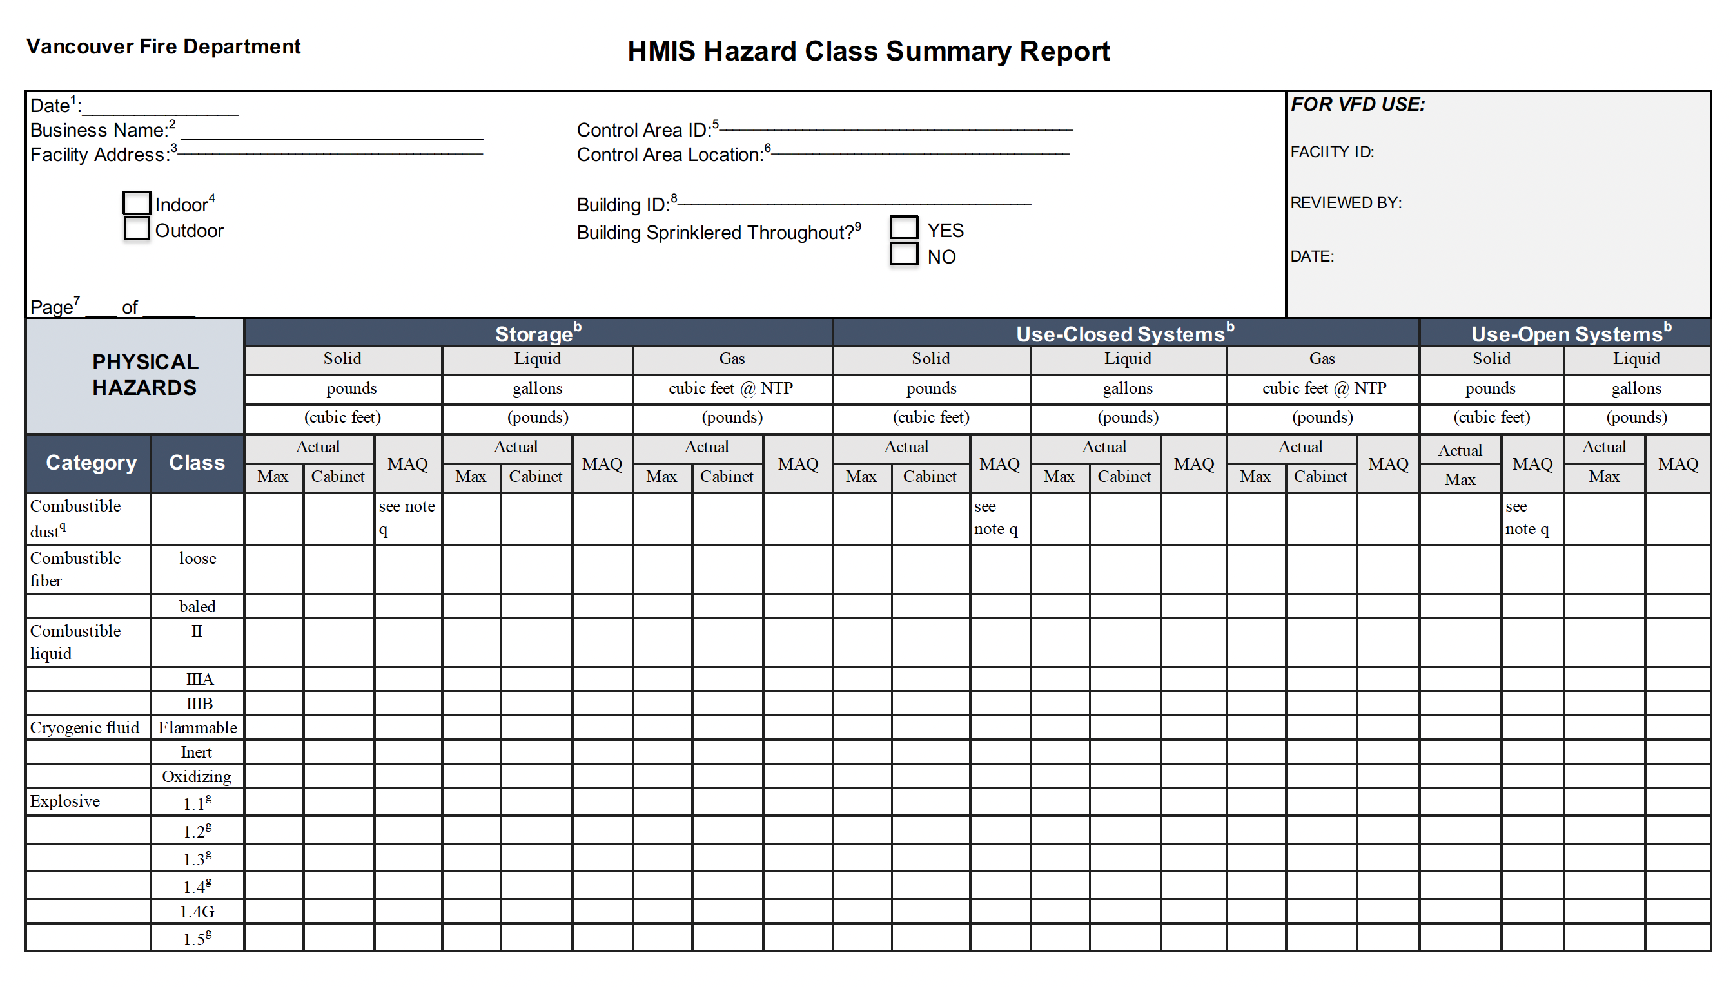

Example of a Completed HMIS Hazard Class Summary Report (Partial view)

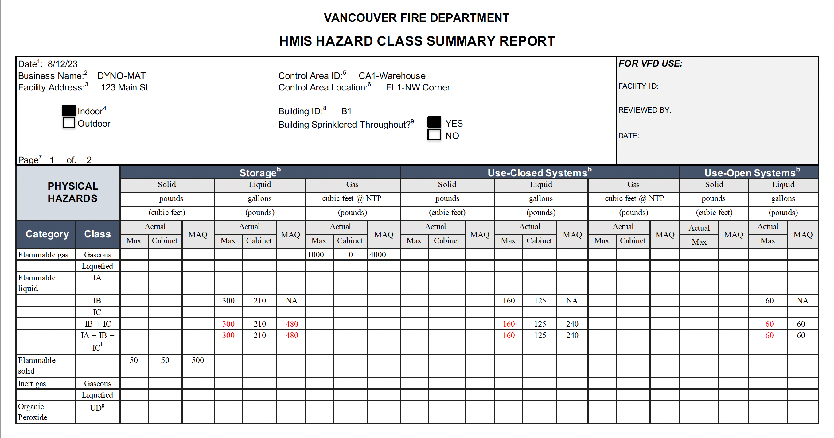

HMIS Hazard Class Summary Report Instructions

Each HMIS must be accompanied by an approved HMIS Hazard Class Summary Report

- DATE - In the space at the top left side of the form, enter the date this inventory statement page was prepared.
- BUSINESS NAME - Enter the complete Facility Name.
- FACILITY ADDRESS – Enter the Facility Address.
- INDOOR / OUTDOOR – Indicate whether the inventory chemicals are located Indoors or Outdoors.
- CONTROL AREA ID – Enter the name of the Control Area. This is a user-defined field.
- CONTROL AREA LOCATION – Identify the specific location of the Control Area, including the building floor level if indoors.
- PAGE NUMBER – Enter the applicable page number and the total number of pages contained in the HMIS.
- BUILDING ID – Enter the name or ID of the Building containing the Control Area or Group H occupancy this HMIS represents. This is a user-defined field.
- BUILDING SPRINKLERED THROUGHOUT – Specify whether the building containing the control area is sprinklered throughout.

ACTUAL MAX - For each Hazard Class and Category aggregate the total maximum quantity of hazardous materials in the control area by physical state for each activity (storage, closed use, open use). This quantity should be displayed in the applicable Actual Max column.
ACTUAL CABINET - For each Hazard Class and Category aggregate the total quantity of hazardous materials in the control area confined to approved storage cabinets, gas cabinets, gas rooms, exhausted enclosures, and approved safety cans by physical state for each activity (storage, closed use, open use). This quantity should be displayed in the applicable Actual Cabinet column.
MAQ - For each Hazard Class and Category, physical state, and activity (storage, closed use, open use), calculate the MAQ allowed by the Code including the increases and decrease based on location and protection features provided. This quantity should be displayed in the applicable MAQ column.

Emergency Response/Contingency Plan

(Hazardous Materials Management Plan)
Authority Cited: International Fire Code Section 5001.5.1 Page____of____

All facilities required to submit an HMMP must have a written emergency response plan. This plan is a required component of the Hazardous Materials Management Plan (HMMP). If you already have a plan that meets these requirements, you should not complete this template plan, but you must include a copy of your existing plan as part of your HMMP.

This site-specific Emergency Response/Contingency Plan is the facility’s plan for dealing with emergencies and shall be implemented immediately whenever there is a fire, explosion, or release of hazardous materials that could threaten human health and/or the environment. At least one copy of the plan shall be maintained at the facility for use in the event of an emergency and for inspection by the local agency. A copy of the plan and any revisions must be provided to any contractor, hospital, or agency with whom special (i.e., contractual) emergency services arrangements have been made (see section 3, below).

Evacuation Plan:
  - The following alarm signal(s) will be used to begin evacuation of the facility (check all that apply):
Bells Horns/Sirens Verbal (i.e., shouting) Other (specify
  - Evacuation map is prominently displayed throughout the facility.
Note: A properly completed HMMP Site Plan satisfies contingency plan map requirements. This drawing (or any other drawing that shows primary and alternate evacuation routes, emergency exits, and primary and alternate staging areas) must be prominently posted throughout the facility in locations where it will be visible to employees and visitors.

a. Emergency Contacts:*
Fire/Police/Ambulance Phone No.: 911
Washington Emergency Management Agency Phone No.:

b. Post-Incident Contacts:*
Vancouver Fire Marshal (VFM) Phone No.: ( ) Local Hazardous Materials Program Phone No.: ( )

c. Emergency Resources:
Poison Control Center* Phone No.:
Nearest Hospital: Name: Phone No.: ( ) Address: City:

Arrangements With Emergency Responders:
If you have made special (i.e., contractual) arrangements with any police department, fire department, hospital, contractor, or State or local emergency response team to coordinate emergency services, describe those arrangements below:

Emergency Response/Contingency Plan (Hazardous Materials Management Plan) Page of

- Emergency Procedures:
Emergency Coordinator Responsibilities:
  - Whenever there is an imminent or actual emergency such as an explosion, fire, or release, the emergency coordinator (or his/her designee when the emergency coordinator is on call) shall:
    - Identify the character, exact source, amount, and areal extent of any released hazardous materials.
    - Assess possible hazards to human health or the environment that may result from the explosion, fire, or release. This assessment must consider both direct and indirect effects (e.g., the effects of any toxic, irritating, or asphyxiating gases that are generated, the effects of any hazardous surface water run-off from water or chemical agents used to control fire, etc.).
    - Activate internal facility alarms or communications systems, where applicable, to notify all facility personnel.
    - Notify appropriate local and state authorities (i.e., call 911).
    - Monitor for leaks, pressure build-up, gas generation, or ruptures in valves, pipes, or other equipment shut down in response to the incident.
    - Take all reasonable measures necessary to ensure that fires, explosions, and releases do not occur, recur, or spread to other hazardous materials at the facility.
  - Before facility operations are resumed in areas of the facility affected by the incident, the emergency coordinator shall:
    - Provide for proper storage and disposal of recovered waste, contaminated soil or surface water, or any other material that results from an explosion, fire, or release at the facility.
    - Ensure that no material that is incompatible with the released material is transferred, stored, or disposed of in areas of the facility affected by the incident until cleanup procedures are completed.
    - Ensure that all emergency equipment is cleaned, fit for its intended use, and available for use.
    - Notify the Fire Marshal that the facility complies with requirements b-i and b-ii, above.
Responsibilities of Other Personnel:
On a separate page, list any emergency response functions not covered in the “Emergency Coordinator Responsibilities” section, above. Next to each function, list the job title or name of each person responsible for performing the function. Number the page(s) appropriately.

Post-Incident Reporting/Recording:
The time, date, and details of any hazardous materials incident that requires implementation of this plan shall be noted in the facility’s operating record.

Within 15 days of any hazardous materials emergency incident or threatened hazardous materials emergency incident that triggers implementation of this plan, a written Emergency Incident Report, including, but not limited to a description of the incident and the facility’s response to the incident, must be submitted to the Vancouver Fire Department, Fire Marshal’s Office. The report shall include:
  - Name, address, and telephone number of the facility’s owner/operator;
  - Name, address, and telephone number of the facility;
  - Date, time, and type of incident (e.g., fire, explosion, etc.);
  - Name and quantity of material(s) involved;
  - The extent of injuries, if any;
  - An assessment of actual or potential hazards to human health or the environment, where this is applicable;
  - Estimated quantity and disposition of recovered material that resulted from the incident;
  - Cause(es) of the incident;
  - Actions taken in response to the incident;
  - Administrative or engineering controls designed to prevent such incidents in the future.

- Earthquake Vulnerability:

As an attachment to this plan, you must identify any areas of the facility and mechanical or other systems that require immediate inspection or isolation because of their vulnerability to earthquake-related ground motion.

- Hazard Mitigation/Prevention/Abatement

As an attachment to this plan, you must include procedures that provide for mitigation, prevention, or abatement of hazards to persons or property. These procedures must be scaled appropriately for the size and nature of the business, the nature of the damage potential of the hazardous materials handled, and the proximity of the business to residential areas and other populations.

Emergency Response/Contingency Plan (Hazardous Materials Management Plan) Page of

- Emergency Equipment:
List the emergency equipment present at the facility.

EMERGENCY EQUIPMENT INVENTORY TABLE

1.  Equipment Category | 2.  Equipment Type | 3.  Locations * | 4.  Description**
Personal Protective Equipment, Safety Equipment, and  First Aid Equipment | Cartridge Respirators
 | Chemical Monitoring Equipment (describe)
 | Chemical Protective Aprons/Coats
 | Chemical Protective Boots
 | Chemical Protective Gloves
 | Chemical Protective Suits (describe)
 | Face Shields
 | First Aid Kits/Stations (describe)
 | Hard Hats
 | Plumbed Eye Wash Stations
 | Portable Eye Wash Kits (i.e., bottle type)
 | Respirator Cartridges (describe)
 | Safety Glasses/Splash Goggles
 | Safety Showers
 | Self-Contained Breathing Apparatuses (SCBA)
 | Other (describe)
Fire Extinguishing Systems | Automatic Fire Sprinkler Systems
 | Fire Alarm Boxes/Stations
 | Fire Extinguisher Systems (describe)
 | Fire Extinguishers (describe)
 | Other (describe)
Spill Control Equipment and  Decontamination Equipment | Absorbents (describe)
 | Berms/Dikes (describe)
 | Decontamination Equipment (describe)
 | Emergency Tanks (describe)
 | Exhaust Hoods
 | Gas Cylinder Leak Repair Kits (describe)
 | Neutralizers (describe)
 | Overpack Drums
 | Sumps (describe)
 | Other (describe)
Communications and  Alarm Systems | Chemical Alarms (describe)
 | Intercoms/ PA Systems
 | Portable Radios
 | Telephones
 | Tank Leak Detection Systems
 | Other (describe)
Additional Equipment (Use Additional Pages if Needed.)
* Use the map and grid numbers from the Storage Map prepared for your HMMP.
** Describe the equipment and its capabilities. If applicable, specify any testing/maintenance procedures/intervals. Attach additional pages, numbered appropriately, if needed.

Employee Training Plan

(Hazardous Materials Management Plan)
Authority Cited: International Code Section 5001.5.1 Page of

All facilities required to submit a HMMP must maintain a written employee training plan. A blank plan has been provided below for you to complete and submit if you do not already have a similar plan. If you already have a brief written description of your training program that addresses all subjects covered below, you are not required to complete the template plan below, but you must include a copy of your existing document as part of your HMMP.

Check all boxes that apply. [Note: Items marked with an asterisk (*) are required.]:

- Personnel are trained in the following procedures:

Internal alarm/notification *
Evacuation/re-entry procedures & assembly point locations*
Emergency incident reporting
External emergency response organization notification
Location(s) and contents of Emergency Response/Contingency Plan
Facility evacuation drills, that are conducted at least (specify): (e.g., “Quarterly”, etc.)

- Chemical Handlers are additionally trained in the following:

Safe methods for handling and storage of hazardous materials *
Location(s) and proper use of fire and spill control equipment
Spill procedures/emergency procedures
Proper use of personal protective equipment *
Specific hazard(s) of each chemical to which they may be exposed, including routes of exposure (i.e., inhalation, ingestion,
absorption) *
Hazardous Waste Handlers/Managers are trained in all aspects of hazardous waste management specific to their job duties.
(e.g., container accumulation time requirements, labeling requirements, storage area inspection requirements, manifesting requirements, etc.) *

- Emergency Response Team Members are capable of and engaged in the following:

Complete this section only if you have an in-house emergency response team
Personnel rescue procedures
Shutdown of operations
Liaison with responding agencies
Use, maintenance, and replacement of emergency response equipment
Refresher training, which is provided at least annually *
Emergency response drills, which are conducted at least (specify): (e.g., “Quarterly”, etc.)

Record Keeping

(Hazardous Materials Management Plan)

Authority Cited: International Code Section 5001.5.1 Page of

All facilities that handle hazardous materials must maintain records associated with their management. A summary of your record keeping procedures is a required component of the Hazardous Materials Management Plan (HMMP). A blank summary has been provided below for you to complete and submit if you do not already have such a document. If you already have a brief written description of your hazardous materials record keeping systems that addresses all subjects covered below, you are not required to complete this page, but you must include a copy of your existing document as part of your HMMP.

Check all boxes that apply. The following records are maintained at the facility. [Note: Items marked with an asterisk (*) are required.]:

Current employees’ training records (to be retained until closure of the facility) *
Former employees’ training records (to be retained at least three years after termination of employment) *
Training Program(s) (i.e., written description of introductory and continuing training) *
Current copy of this Emergency Response/Contingency Plan *
Record of recordable/reportable hazardous material/waste releases *
Record of hazardous material/waste storage area inspections *
Record of hazardous waste tank daily inspections *
Description and documentation of facility emergency response drills
Note: The above list of records does not necessarily identify every type of record required to be maintained by the facility.

Facility Site Plan and Storage Map
(Hazardous Materials Management Plan)
Authority Cited: International Code Section 5001.5.1

A Site Plan (public document) and Storage Map (confidential document) must be included with your HMMP or HMIS. For relatively small facilities, these documents may be combined into one drawing. However, if combined, the combined Site Plan/Storage Map will become a public document. If you are concerned about displaying the storage locations of hazardous materials to the public, you must provide a separate facility Storage Map. Since these drawings are intended for use in emergency response situations, larger facilities (generally those with complex and/or multiple buildings) should provide an overall site plan and a separate storage map for each building/storage area. A blank Facility Site Plan/Storage Map sheet has been provided on the following page. You may complete that page or attach any other drawing(s) that contain(s) the information required below:

- Site Plan (public document): This drawing shall contain, at a minimum, the following information:

  - An indication of North Direction;
  - Approximate scale (e.g., “1 inch = 10 feet”.);
  - Date the map was drawn;
  - All streets bordering the facility;
  - Locations of all buildings and other structures;
  - Parking lots and internal roads;
  - Hazardous materials loading/unloading areas;
  - Outside hazardous materials storage or use areas;
  - Storm drain and sanitary sewer drain inlets;
  - Wells for monitoring of underground tank systems;
  - Primary and alternate evacuation routes, emergency exits, and primary and alternate staging areas.

- Storage Map (confidential): The map(s) shall contain, at a minimum, the following information:

  - General purpose of each section/area within each building (e.g., “Office Area”, “Manufacturing Area”, etc.);
  - Location of each hazardous material/waste storage, dispensing, use, or handling area (e.g., individual underground tanks, aboveground tanks, storage rooms, paint booths, etc.). Each area shall be identifiable by a Grid Number, to be used in conjunction with the Hazardous Materials Inventory Statement (HMIS) of the HMMP;
  - For tanks, the capacity limit in gallons and common name of the hazardous material contained in each tank;
  - Entrances to and exits from each building and hazardous material/waste room/area;
  - Location of each utility emergency shut-off point (i.e., gas, water, electric.);
  - Location of each monitoring system control panel (e.g., underground tank monitoring, toxic gas monitoring, etc.).

Facility Site Plan/Storage Map

(Hazardous Materials Management Plan)
Authority Cited: International Code Section 5001.5.1

Site Address:

Date Map Drawn: Map Scale: Page of

Note container sizes and materials

 | A | B | C | D | E | F | G | H | I | J | K | L | M | N | O | P | Q | R | S | T | U | V | W | X | Y | Z
1
2
3
4
5
6
7
8
9
10
11
12
13
14
15
16
17
18
19
20
21
22
23
24
25
26
27
28

Vancouver Fire Department

Refrigerant Declaration
Authority Cited: International Fire Code 105.2

Date:

Project Address:

Project Name:

Refrigerant System Details on Shop Drawing Page No.:

Project is:
New system Substantial alteration

Change of refrigerant

Based on the 2021 International Mechanical Code (IMC) Table 1103.1:

Chemical Refrigerant: R- Refrigerant Name: __________________________

Refrigerant Class: A1 A3
A2 B1
A2L (per ASHRAE 34) B2

Maximum quantity of refrigerant contained in the closed system: ___________lbs.

Maximum quantity of spare refrigerant stored onsite, outside of the closed system: ______________lbs.

I declare that the information provided above is true and correct.

Name (Print): ______________________________ | Title: _________________________________
Signature: _________________________________ | Date: _________________________________

Hazardous Materials Tank Plan
Authority Cited: International Fire Code 105.2

Facility Address:
Facility Name:
Tank Plan Details on Architectural Plan Page No.:

This project includes:
New Existing Aboveground storage tanks (AST). Number of ASTs: ___________
New Existing Underground storage tanks (UST). Number of USTs: ___________

A Tank Plan Details Page is included in the Architectural Plan Set containing detailed information about each new Stationary and portable tank as well as a Tank Plan Table that provides at least the following information for each hazardous materials tank, including existing tanks:
- Tank ID
- Tank capacity
- Aboveground (AST) or underground (UST) tank
- Name and concentration of hazardous material contained
- Hazard class(es) of material contained
- New or existing

Example of Tank Plan Table:
TANK ID | CAPACITY (gal) | AST/UST | NAME | HAZARD CLASS | NEW/EXISTING
TK-108 | 10,000 | AST | 100% Hydrogen | Flammable Liquefied Gas | New
TK-110 | 500 | AST | 35% Hydrogen peroxide | Class 2 oxidizer, Corrosive | New
TK-112 | 5,000 | AST | 50% Sulfuric acid | Class 1 Water reactive, Toxic, Corrosive | Existing

Supplemental documents:
Additional information for each tank may be required by the fire code official, including but not limited to, the following:
- Manufacturer’s cut sheets that include the tank design standard.
- Cut sheets on tank vents, overfill prevention devices, piping, pumps, and other ancillary equipment.
- Fire protection coating for AST support legs.
- Calculations demonstrating compliance of spill control, secondary containment and or drainage capacity.
- Location and design of areas designated for tank vehicles during filling and/or removal operations.
- Documentation and results of third-party tank system testing.
- A copy of any Spill Prevention, Control, and Countermeasure Plan required by, and developed for, the Washington State Department of Ecology.
Vancouver Fire Department
Life Safety Matrix
Authority Cited: International Fire Code 901.2

I. POLICY
When required by the Vancouver Fire Marshal, a Life Safety Matrix, developed and signed off by a qualified design professional, must be submitted with new construction and operational permit applications. The Matrix is required to be updated and resubmitted when a modification is made that either adds new, or impacts existing, life safety systems. The most recent revision should be shown on the Matrix in an enclosed cloud shape.

II. PURPOSE
Like a Fire Protection input/output Matrix, a Life Safety Matrix defines the sequence of operations relating system inputs to outputs in a relational grid. In a Life Safety Matrix, the inputs are from each required life safety system at a facility, including, but not limited to, gas detectors, overfill prevention, exhaust flow indicators, and temperature control systems.

LIFE SAFETY SYSTEMS. Systems, devices, and equipment that enhance or facilitate evacuation, smoke control, compartmentation and/or isolation. [IFC 202]

This document is key to the proper design of any life safety system and is also crucial when performing testing to ensure that all these systems are working as intended. Output responses are typically categorized and displayed by Control Unit Annunciations, Notifications, Required Life Safety Controls and Supplementary.

III. LIFE SAFETY MATRIX EXAMPLE

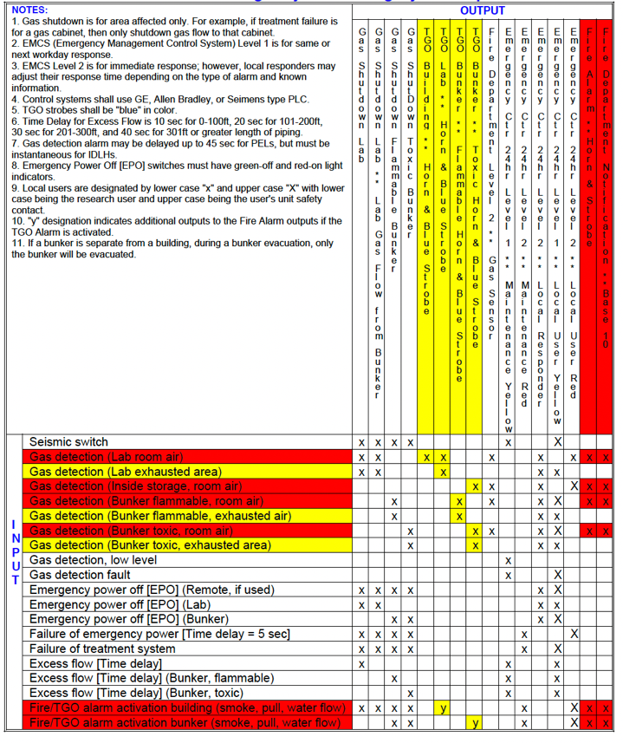

IV. FIRE PROTECTION SYSTEM INPUT/OUTPUT MATRIX EXAMPLE

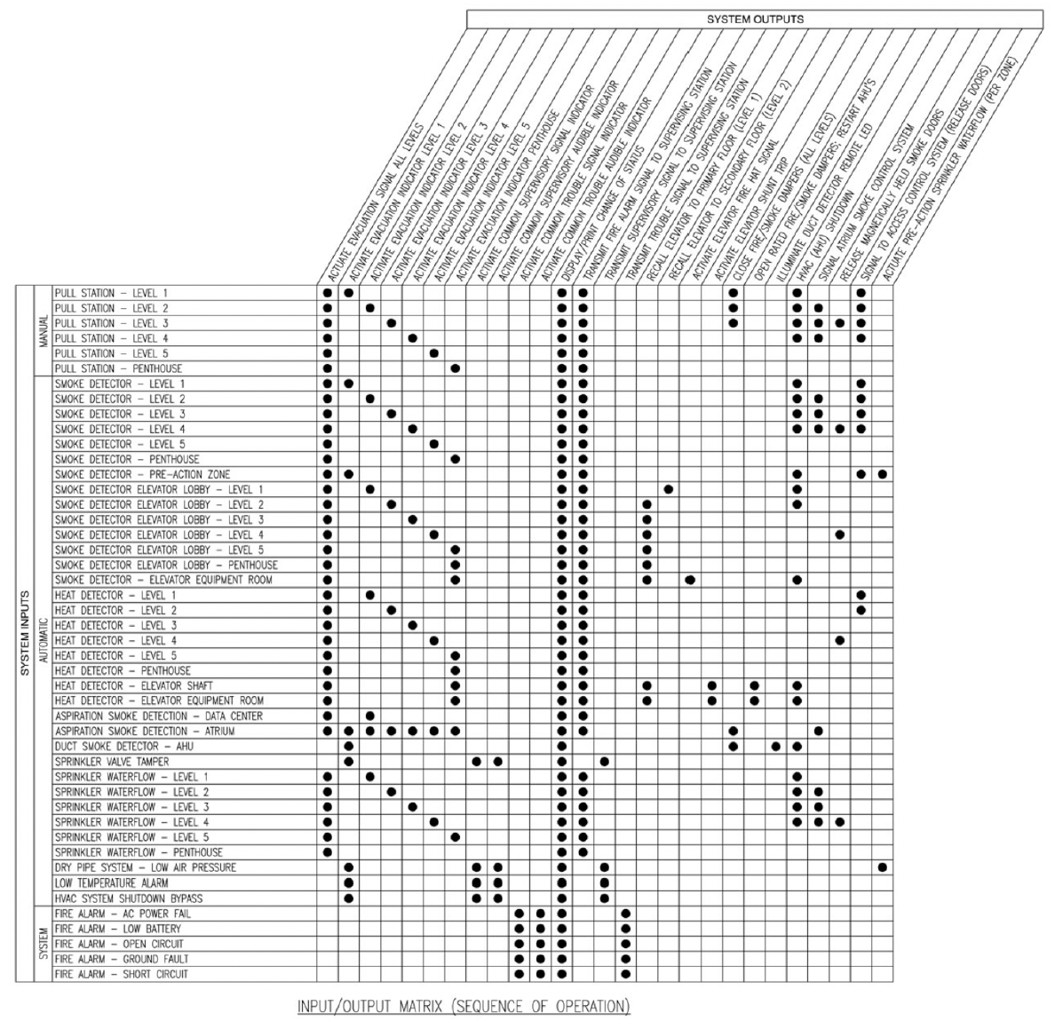

Vancouver Fire Department

ENERGY STORAGE SYSTEMS (ESS) AND

LITHIUM-ION & LITHIUM-METAL BATTERY STORAGE NOTIFICATION

Authority Cited: International Fire Code 1207.1.3 & 1207.1.4

ESS permit requirement.
Stationary and mobile Electrical Energy Storage Systems (ESS) having battery technologies and an energy storage capacity exceeding that listed in IFC Table 1207.1.1 below are required to apply for and obtain a construction and operating permit.

IFC TABLE 1207.1.1
ENERGY STORAGE SYSTEM (ESS) THRESHOLD QUANTITIES
TECHNOLOGY | ENERGY CAPACITY ª
Capacitor ESS | 3 kWh
Flow batteries ^{b} | 20 kWh
Lead-acid batteries, all types | 70 kWh
Lithium-ion batteries | 20 kWh
Nickel metal hydride (Ni-MH) | 70 kWh
Nickel-cadmium batteries (Ni-Cd) | 70 kWh
Other battery technologies | 10 kWh
Other electrochemical ESS technologies | 3 kWh
For SI: 1 kilowatt hour = 3.6 megajoules.
a. Energy capacity is the total energy capable of being stored (nameplate rating), not the usable energy rating.
For units rated in amp-hours, kWh.
shall equal rated voltage times amp-hour rating divided by 1,000.
b. Shall include vanadium, zinc-bromine, polysulfide-bromide and other flowing electrolyte-type technologies.
c. Fifty gallons of lead-acid battery electrolyte shall be considered equivalent to 70 kWh.

Required construction documents.
The following information shall be submitted with each ESS permit application:

1. Location and layout diagram of the room or area in which the ESS is to be installed.
2. Details on the hourly fire-resistance ratings of assemblies enclosing the ESS.
3. The quantities and types of ESS to be installed.
4. Manufacturer’s specifications, ratings, and listings of each ESS.
5. Description of energy (battery) management systems and their operation.
6. Location and content of required signage.
7. Details on fire suppression, smoke or fire detection, thermal management, ventilation, exhaust and deflagration venting systems, if provided.
8. Support arrangement associated with the installation, including any required seismic restraint.
9. A commissioning plan complying with IFC Section 1207.2.1.
10. A decommissioning plan complying with IFC Section 1207.2.3.

Hazard mitigation analysis.
A failure modes and effects analysis (FMEA) or other approved hazard mitigation analysis shall be provided in accordance with IFC Section 104.8.2 for ESS under any of the following conditions:
1. Where ESS technologies not specifically identified in Table 1207.1 are provided.
2. More than one ESS technology is provided in a room or enclosed area where there is a potential for adverse interaction between technologies.
3. Where allowed as a basis for increasing maximum allowable quantities. See Section 1207.5.2.

The hazard mitigation analysis shall evaluate the consequences of the following failure modes. Only single failure modes shall be considered.
1. A thermal runaway condition in a single ESS rack, module, or unit.
2. Failure of any battery (energy) management system.
3. Failure of any required ventilation or exhaust system.

COMPLETE THE FOLLOWING SECTION AND TABLE FOR ESS:

Facility Address:
Facility Name:
ESS Details on Architectural Plan Page No.:

IFC TABLE 1207.5
MAXIMUM ALLOWABLE QUANTITIES OF ELECTROCHEMICAL ESS
TECHNOLOGY USED  Y/N | TECHNOLOGY | MAXIMUM ALLOWABLE QUANTITIES ª  (kWh) | MAXIMUM  ENERGY CAPACITY  (kWh)
 | STORAGE BATTERIES
 | Flow batteries | 600
 | Lead-acid batteries ^{b} | Unlimited
 | Lithium-ion batteries | 600
 | Nickel metal hydride (Ni-MH) | Unlimited
 | Nickel-cadmium batteries (Ni-Cd) | Unlimited
 | Other battery technologies | 200
 | CAPACITORS
 | All types | 20
 | OTHER ELECTROCHEMICAL ESS
 | All types | 20

For SI: 1 kilowatt hour = 3.6 megajoules.
a. For electrochemical ESS units rated in amp-hours, kWh shall equal rated voltage times the amp-hour rating divided by 1,000.
b. Shall include vanadium, zinc-bromine, polysulfide-bromide, and other flowing electrolyte-type technologies.

COMPLETE FOR LITHIUM-ION AND LITHIUM-METAL BATTERY STORAGE:

Facility Address:
Facility Name:
Lithium-ion and Lithium-metal Storage Details on Architectural Plan Page No.:

Not including the following exceptions, are more than 15 cubic feet of lithium-ion and lithium-metal batteries stored at this facility?
Yes No

Exceptions:
1. Batteries installed in the equipment, devices, or vehicles they are designed to power.
2. Batteries packed for use with the equipment, devices, or vehicles they are designed to power.
3. Batteries in original retail packaging that are rated at 300 watt-hours or less for lithium-ion batteries or contain 25 grams or less of lithium metal for lithium metal batteries.
4. Temporary storage of batteries or battery components during the battery manufacturing process prior to completion of final quality control checks.

If yes, what is the total volume of lithium-ion and lithium-metal batteries stored indoors? ________ cu. ft.

What is the total volume of lithium-ion and lithium-metal batteries stored outdoors? ____________ cu. ft.

I declare that the information provided above is true and correct.
Name (Print): _______________________________ | Title: _______________________________
Signature: __________________________________ | Date: _______________________________

Multi-Tenant Building Control Area Agreement

(Hazardous Materials Management Plan)
Authority Cited: International Fire Code Section 105.2

I. PURPOSE

Multi-tenant properties and businesses are located throughout the City of Vancouver. The Fire Code establishes the maximum number of ‘control areas’ in a building and maximum quantities of hazardous materials allowed in each control area. Before the fire code official can properly evaluate compliance with Code requirements in multi-tenant buildings, it is imperative to know the number of control areas and percent of the maximum allowable quantities (MAQs) an individual tenant is authorized by the building owner to occupy.

II. APPLICABILITY

This Policy applies to tenants of multi-tenant buildings that apply for a hazardous materials operating or construction permit or are otherwise required to submit a Hazardous Materials Management Plan (HMMP) or Hazardous Materials Inventory Statement (HMIS).

III. POLICY

Where applicable, each application for a hazardous materials operating permit, or hazardous materials construction permit, shall include an approved Multi-building Control Area Agreement signed by the building owner or their representative, or equivalent approved documentation. Similarly, where required by the fire code official, businesses in multi-tenant buildings required to submit a Hazardous Materials Management Plan (HMMP) or Hazardous Materials Inventory Statement (HMIS), shall submit an approved Multi-building Control Area Agreement signed by the building owner or their representative, or equivalent approved documentation.

The Agreement must prescribe the number and location of the building control area(s) the applicant is allowed to occupy in adequate detail and the percent of the maximum allowable quantities of hazardous materials within each control area the applicant is authorized to utilize. A floor plan that illustrates the designated boundaries of each control area is also required.

The preferred documentation is a copy of the Control Area clause, including any supporting documentation, in the applicant’s lease agreement with the building owner/operator. If such a clause does not exist in the applicant’s lease agreement, a completed Multi-tenant Control Area Agreement form will satisfy the requirement.

IV. AGREEMENT EXAMPLES

Example 1:
Control Areas. Tenant shall have the use of 100% of the control area designated as control area B1-1 on Exhibit H attached hereto. For the avoidance of doubt, Tenant shall not have rights with respect to any other control area at the Project.

Note: In this case a copy of Exhibit H would also be required to be submitted to the fire code official.

***********
Example 2:
Control Areas. In addition to the Hazmat Storage Space described in Section 24.38 below, Tenant shall have two (2) dedicated control areas on the third (3rd) floor of the building and the right to use its pro rata share of the control area on the fourth (4th) floor of the building (collectively, the "Control Areas"). Such Control Areas are more particularly described on Exhibit I attached hereto.

Note: In this case, a copy of Section 24.38 of the lease and Exhibit I would also be required to be submitted to the fire code official.

Vancouver Fire Department
Multi-Tenant Building Control Area Agreement
Authority Cited: International Fire Code Section 105.2

I. TENANT FACILITY
TENANT BUSINESS NAME (Same as Facility Name or DBA – Doing Business As) |  |  |  |  | BUSINESS PHONE  ( )
BUSINESS SITE ADDRESS |  |  |  |  | BUSINESS FAX  ( ) |  |  | .
BUSINESS SITE CITY | WA | ZIP CODE . |  |  | COUNTY
BUSINESS MAILING ADDRESS
BUSINESS MAILING CITY |  |  | STATE |  |  |  | ZIP CODE
BUSINESS OPERATOR NAME |  |  |  | BUSINESS OPERATOR PHONE  ( )
II. BUSINESS OWNER
OWNER NAME |  |  |  | OWNER PHONE  ( )
OWNER MAILING ADDRESS
OWNER MAILING CITY |  |  | STATE |  |  |  | ZIP CODE
III. BUILDING OWNER OR DESIGNATED REPRESENTATIVE
BUILDING OWNER NAME |  |  |  | CONTACT PHONE  ( )
BUILDING OWNER MAILING ADDRESS |  |  |  | CONTACT EMAIL
BUILDING OWNER MAILING CITY |  |  | STATE |  |  |  | ZIP CODE

Enter Control Area Agreement Text here:

Certification: Based on my inquiry of those individuals responsible for obtaining the information, I certify under penalty of law that I have personally examined and am familiar with the information submitted and believe the information is true, accurate, and complete.
SIGNATURE OF BUILDING OWNER/OPERATOR OR DESIGNATED REPRESENTATIVE | DATE | NAME OF DOCUMENT PREPARER
NAME OF SIGNER (print) | TITLE OF SIGNER

Vancouver Fire Department
Biosafety Level-3 or -4 Activity Notification
Authority Cited: International Fire Code Section 105.2

Some research and development laboratories work with biological agents and toxins infectious to humans, such as parasites, viruses, bacteria, fungi, prions, and biologically active materials such as toxins, allergens, and venoms.

“Biosafety Levels” (BSLs) are designations applied to laboratory activities based on the severity of the health-related risk associated with the work conducted. BSL-1, BSL-2, BSL-3, and BSL-4 describe the minimum protective measures needed to protect workers, the environment, and the public. BSL-4 is the highest biosafety level and requires the highest (maximum) level of containment.

The Fire Code does not regulate biological agents and toxins. However, BSL-3 and BSL-4 laboratories are of significant concern to the Vancouver Fire Department and emergency responders since by definition:

BSL-3 agents:
- Are associated with human disease and cause illness by spreading through the air (aerosol)
- Cause diseases that may have severe or lethal consequences

BSL-4 agents:
- Are associated with human disease and cause illness by spreading through the air (aerosol) or have an unknown cause of transmission
- Cause diseases that are usually life-threatening

Being informed of where BSL-3 and BSL-4 activities occur in the city allows VFD to adjust response protocols accordingly to help ensure the safety of emergency responders and the public.

COMPLETE FOR BSL

Facility Location:

Facility Name:

Specific location(s) of BSL activity:

Designation of BSL activity:

BSL-3 BSL-4

I declare that the information provided above is true and correct.

Name (Print): ______________________________ | Title: _________________________________
Signature: _________________________________ | Date: _________________________________

HIGH-PILED OR RACK STORAGE

SUPPLEMENTAL APPLICATION
Occupancy Address:
Tenant:
Telephone:

Please answer all questions to the best of your ability, The detail of the description will help establish your commodity classification and storage fire protection requirements.

If you cannot answer these questions, please contact the Vancouver Fire Department at (360) 487-7260 or via e-mail at vanfmo@cityofvancouver.us. You may have to retain the services of a qualified fire protection engineer to evaluate the hazard and prepare a report for fire department review.

Mixed commodity classifications must be protected to the highest commodity classification shown unless it can be proved by engineering analysis the fire protection equipment can protect the hazard.

- Describe the commodities to be stored. Provide a detailed description or engineering report of the product(s), packing materials and containers. Products that are packaged with Group A expanded or non-expanded plastics should be described with the amount of each plastic by weight or volume. The engineering report should state the current commodity class.

- Describe the method of storage. Provide a description of the method of storage such as in solid piles, on pallets (wood, steel or plastic), loose, racks (single, double or multiple-row), carousel, flow-through, bin box, etc.

- Specify the amount of building area designated for high piled storage. Sq. ft.

- Specify the maximum height the material will be stored. feet

FIRE DEPARTMENT USE ONLY
❑
Based on the information provided, the Vancouver Fire Department has determined your commodity classification is Class , and the storage area is Class . Deviations from the information supplied may require additional fire protection features.
❑
The Vancouver Fire Department is unable to classify your commodities. You are required to provide a fire code engineering analysis for review and approval.

Please provide the following materials and/or information listed on the next page.

GENERAL

[ ] Floor plan showing the locations and dimensions of high-piled storage areas. [ ] Location of required fire department access doors.
[ ] A description of the type of fire suppression and detection systems. Separate plans may be submitted for review later.
[ ] Type, location, dimensions and specifications of smoke removal and curtain board systems. [ ] Location within storage areas of each commodity by class.
[ ] Location of commodities that are banded or encapsulated. [ ] Useable storage height for each storage area.
[ ] Clearance between the top of storage and sprinkler deflectors for each area. [ ] Aisle dimensions between each storage array.
[ ] Evacuation plan for areas that are accessible to the public.

If storage is on racks or shelves:

[ ] Verification the system is rack or shelf storage, or bin boxes greater than five (5) feet in any dimension.
[ ] Number of tiers within each rack, shelf or bin box system. [ ] The use of solid or slatted decks.
[ ] Location and anticipated quantity of plastic pallets or bin boxes, if applicable. [ ] Description of material from which plastic pallets or bin boxes are made.
[ ] Dimension and location(s) of transverse and longitudinal flue spaces.
[ ] Location and anticipated quantity of idle pallet storage area, if applicable.

If storage is solid-piled, palletized or small bin boxes:

[ ] Verification the system is solid-pile, palletized, shelves less than fifteen (15) feet high or bin boxes smaller than five (5) feet in any dimension.
[ ] Pile dimensions (length, width and height) for each storage array. [ ] Maximum pile volume for each storage array.
[ ] Location and anticipated quantity of plastic pallets or bin boxes, if applicable. [ ] Description of material from which plastic pallets or bin boxes are made.
[ ] Location and anticipated quantity of idle pallet storage area, if applicable.

If you have questions, please contact us at (360) 487-7260 or via e-mail at vanfmo@cityofvancouver.us.

AEROSOL STORAGE AND SALES

OWNER’S STATEMENT OF INTENDED USE
Occupancy Address:
Tenant:
Telephone:
Owner:
Telephone:
Owner’s Address:
Gross Building Area: sq. ft.
Designated storage are(s): sq. ft.

The Vancouver Fire Department’s review of this project indicates there is a potential for it to be used for storage and/or sales of hazardous aerosol products as defined by the local fire code. If this is the case, special fire protection features may be required beyond those specified in the initial building permit plan review.

Please check the appropriate box below, sign and return this form to the Vancouver Fire Department. If you have questions, please contact us at (360)487-7260 or via e-mail at vanfmo@cityofvancouver.us. If additional fire protection features are required, you will be notified in writing.

Aerosol products are classified as Level 1, 2, or 3 depending upon their chemical composition and propellant gas. Classifications can be obtained from the Safety Data Sheet (SDS) for the product or from the box in which they are shipped. SDS’s are available from the product manufacturer or distributor. Please note: If aerosol-containing cartons are not marked to identify their classification, they are treated as Level 3 aerosols.

[ ] This building will not be used for storage or retail display of five hundred (500) pounds net weight or more of Level 2 or 3 aerosols, or any amount of aerosols packaged in vent-release containers.

[ ] This building will be used for storage or retail display of five hundred (500) pounds net weight or more of Level 2 or 3 aerosols, or any amount of aerosols packaged in vent-release containers. A fire department permit is required.
NOTE: If you checked this box, please complete the attached supplemental form.

[ ] This building is a speculation building without a tenant at this time. The owner will notify the tenant that there may be special fire department requirements for aerosol storage and/or retail display, and will be advised to contact the fire department for permits prior to occupancy.

Owner’s signature Date

Please answer all questions. The detail of the description will help establish accurate code requirements.

Aerosol products are classified as Level 1, 2, or 3 depending upon their chemical composition and propellant gas. Classifications can be obtained from the Safety Data Sheet (SDS) for the product or from the box in which they are shipped. SDS’s are available from the product manufacturer or distributor. Please note: If aerosol-containing cartons are not marked to identify their classification, they are treated as Level 3 aerosols.

Retail sales and Display. Provide an estimated maximum quantity of the aerosols you intend to have in retail display at any time. (One pallet load of aerosols is approximately five hundred (500) net pounds.)

Maximum Net Pounds
Level 2
Level 3
Vent Release Containers

- Storage. Provide an estimated maximum quantity of the aerosols you intend to have in storage at any time. (One pallet load of aerosols is approximately five hundred (500) net pounds.)

Maximum Net Pounds
Level 2
Level 3
Vent Release Containers

- Storage Array. Storage will be on:

[ ] Shelves [ ] Racks [ ] Pallets [ ] Other

Shelf storage normally includes those shelves less than thirty (30) inches deep with shelves usually two
(2) feet apart vertically. Rack storage includes larger storage arrangements and structures.

- Height. The maximum storage height of aerosol containers will be feet. Aerosols in retails display may not exceed eight (8) feet in height on shelves, or six (6) feet in cartons.

- Aisles. Aisles around storage will be feet wide. Aerosols in retail displays must have aisle widths four (4) feet wide on three (3) sides of the display.

- Relocation. Once you have established the designated display or storage area, do you intend to move your aerosols? [ ] Yes [ ] No

Moving the aerosol storage or display may affect the performance of the building’s fire sprinkler system. A permanently designated storage and display may be less costly.

FLAMMABLE AND COMBUSTIBLE LIQUID STORAGE IN WHOLESALE AND RETAIL SALES

OWNER’S STATEMENT OF INTENDED USE
Occupancy Address:
Tenant:
Telephone:
Owner:
Telephone:
Owner’s Address:
Gross Building Area: sq. ft.
Designated storage area(s): sq. ft.

The Vancouver Fire Department’s review of this project indicates there is a potential for it to be used for the storage and/or sales of flammable or combustible liquids as defined by the local fire code. If this is the case, special fire protection features may be required beyond those specified in the initial building permit plan review.

Please check the appropriate box below, sign and return this form to the Vancouver Fire Department. If you have questions, please contact us at (360) 487-7260 or via e-mail at vanfmo@cityofvancouver.us. If additional fire protection features are required, you will be notified in writing.

Flammable and combustible liquids are classified as Class I-A, I-B, I-C, II, III-A or III-B depending upon their flash point and boiling temperatures. Classifications can be obtained from the Safety Data Sheet (SDS). SDS’s are available from the product manufacturer or distributor.

[ ] This building will not be used for storage or retail display of flammable or combustible liquids exceeding the amounts listed on the top of the next page.

[ ] This building will be used for storage or retail display of flammable or combustible liquids exceeding the amounts listed on the top of the next page. A fire department permit is required.
NOTE: If you checked this box, please complete Part Two of this form.

[ ] This building is a speculation building without a tenant at this time. The owner will notify the tenant that there may be special fire department requirements for flammable or combustible liquid storage and/or retail display and will be advised to contact the fire department for permits prior to occupancy.

Owner’s signature Date

MAXIMUM ALLOWABLE QUANITITES PER CONTROL AREA
(Gallons)

 | Non-sprinklered Building | Sprinklered Building*
Class I-A | 30 | 60
Class I-B, I-C, II, III-A | 1,600 | 7,500
Class III-B | 13,200 | Unlimited

A control area is a space separated from the remainder of the building by one-hour fire resistive construction.

* To qualify as sprinklered, special water application rates are required, and the ceiling height must not exceed 18 feet. Please have your sprinkler contractor contact the fire department for guidance.

PART TWO

  - Container Sizes and Construction. The maximum size of any one container will not exceed gallons.

Class I and II flammable and combustible liquids will be stored in [ ] metal and/or [ ] plastic containers.

  - Storage array. Storage will be on:

[ ] Shelves [ ] Racks [ ] Pallets [ ] Other

Shelf storage normally includes those shelves less than thirty (30) inches deep with shelves usually two (2) feet apart vertically. Rack storage includes larger storage arrangements and structures.

  - Height. The maximum storage height of containers will be feet. Maximum storage height is limited by the type of fire protection provided. The maximum storage height will be specified on your fire department permit.

