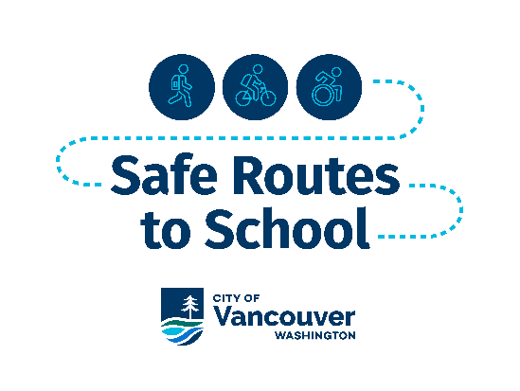
Safe Routes Checklist:

Name: __________________________

School: _________________________

Date: ___________________________

Use this Safe Routes to School route checklist to assess the conditions on your route to school and write down your observations of what it is like to walk, roll or bike to school in your neighborhood.
- Choose your route to or from school.
- Print a map of your neighborhood that includes your route.
- Walk or roll along your route and complete this checklist as you go. You can also make notes on your map.
- Submit your completed checklist and map to the Safe Routes to School (SRTS) Program team at: VancouverMoves@cityofvancouver.us

Is there room to walk or roll to school? (Yes or No)
 | Yes | No
 |  |  | The sidewalk is in good condition clear of obstacles.
 |  |  | The sidewalks have ramps for people using wheelchairs, walkers and strollers.
 |  |  | There are some areas where sidewalks are missing, blocked, or are not usable.
 |  |  | There are no sidewalks, but there is a paved shoulder
 |  |  | There are no sidewalks and there is not a paved shoulder.
- Other: _________________________________________________________
- Describe where there are issues or missing sidewalks: _______________________________________________________________

Overall, walking or rolling to school feels (circle one):


Is there room to bike, skate or scooter to school? (Yes or No)
Yes | No
 |  | I ride on the sidewalk:
 |  | It is in good condition and clear of obstacles.
 |  | There are some areas where sidewalks are missing, blocked, or are not usable.
 |  | There are ramps for people using wheelchairs, walkers and strollers.
Yes | No
 |  | I ride on the street:
 |  | There is a bike lane where I ride, skate or scooter to school.
 |  | There is not a bike lane but there is a shared street marking.
 |  | There is not a bike lane but there is a paved shoulder.
- Other: _____________________________________________________________
- Describe where it is difficult to bike, skate or scooter: ___________________________________________________________________

Overall, biking, skating or scooting to school feels (circle one):

Can you safely cross the street? (Yes or No)
Yes | No
 |  | All crosswalks are well marked.
 |  | There is street lighting where I cross the street.
 |  | Some crosswalks are not well marked.
 |  | There are no crosswalks, but the road feels safe to cross.
 |  | There is a traffic signal or yellow flashing lights.
 |  | There is a sound that tells you when it is safe to cross
 |  | The road is too wide to cross.
- Other: _____________________________________________________________
- Describe where it is difficult to bike, skate or scooter: ___________________________________________________________________

Overall, crossing the street on my way to school feels (circle one):

Are drivers looking out for other people on the street? (Yes or No)
Yes | No
 |  | Drivers stop for me and give me enough room.
 |  | Drivers are paying attention.
 |  | Drivers are going too fast.
- Other: ______________________________________________________
- Describe where there are issues with drivers: ___________________________________________________________

Overall, driver behavior on my way to school makes me feel (circle one):

Was there anything else that made your route unpleasant? (check all that apply)

- Not enough street trees or shade.
- Too many vacant lots or rundown buildings.
- Not enough benches or places to rest.
- Not enough streetlights.
- Scary people.
- Scary dogs or other animals.
- Lots of trash.
- Other: __________________

Additional comments about your route to school:
________________________________________________________________________
________________________________________________________________________
________________________________________________________________________
________________________________________________________________________

